Answer on the last:

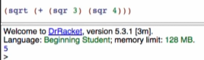

On irrational numbers

 -> 

- decimal representation is infinitely long

- #i means it is an inexact number

- pretty close on that number but not exactly that number